[**VISUAL PHYSICS ONLINE**](http://www.physics.usyd.edu.au/teach_res/hsp/sp/spHome.htm)

**MODULE 7 NATURE OF LIGHT**

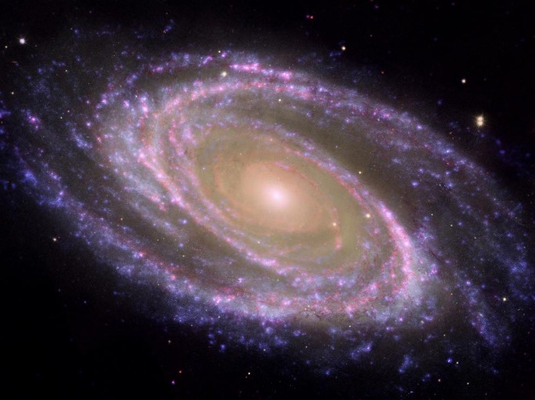

**ELECTROMAGNETIC WAVES**

**WHAT IS LIGHT?**

**James Clerk Maxwell** (1831-1879), was a Scottish mathematician and theoretical physicist. He had an unquenchable curiosity from an early age. Maxwell even his early years made many contributions to science. However, his most significant achievement was the development of **electromagnetic theory**.

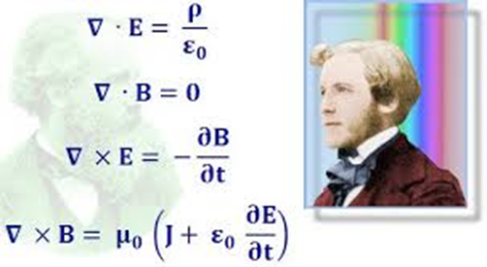

He synthesized all previously unrelated observations, experiments, and equations of electricity, magnetism, and even optics into one consistent theory. Basically, all electric and magnetic phenomena can be described by **Maxwell’s four equation**.

**Maxwell’s equations in integral form in free space** (you don’t need to know these equations. However, these equations show the power of mathematics and how electrical and magnetism can be unified.)

**Gauss’s Law (electricity)**: electric flux is equal to the net charge inside a volume surrounded by the surface *A.* Coulomb’s law can be derived from Gauss’s law for electricity.



**Gauss’s Law (magnetism)**: magnetic flux through a closed surface is zero. This implies that magnetic field lines must form continuous loops with no starting of ending points.



**Faraday’s Law**: A changing magnetic flux produces an electric field. A changing magnetic flux induces an emf in a loop through which the magnetic flux changes.



**Ampere’s Law**: A current and a changing electric flux produce a magnetic field.



These four Maxwell equations form the basis of all computations involving electromagnetic waves (Light: radio, microwave, infrared, visible light, ultraviolet, X-rays and gamma-rays).

Around 1862, Maxwell calculated the speed of propagation of the electromagnetic field. His result was approximately equal to the known value for the speed of light at the time. He concluded:

“We can scarcely avoid the conclusion that light consists in the transverse undulations of the same medium which is the cause of electric and magnetic phenomena”.

Whereas, Newton’s work first unified mechanics, Maxwell’s work in electromagnetism has been referred to as the second great unification in physics.

Sadly, Maxwell died of abdominal cancer at the early age of 48.

So, through the work of Maxwell and later Einstein, we now know that the electric and magnetic fields can work together to create travelling waves called **electromagnetic waves**.

Maxwell use his equations to predict the speed of propagation of the electric and magnetic fields in vacuum. The result was



where the properties of free space (vacuum) are described by the constants

permittivity of free space



permeability of free space



Our picture of an electromagnetic wave is of a combination of varying electric and varying magnetic fields. The varying electric field produces a varying magnetic field, but the varying magnetic field produces a varying electric field. So, the electromagnetic wave regenerates itself as it moves through space. An electric disturbance acts as a source in which energy is transferred away from the source by electromagnetic waves propagating at the speed of light. The oscillations of the electric and magnetic fields are in-phase and perpendicular to each other and perpendicular to the direction of propagation. Therefore, electromagnetic waves are transverse waves. In the mathematical analysis of Maxwell’s equations, the speed of propagation is independent of any medium and Einstein concluded the remarkable fact that the speed of light is a constant and does not depend upon the relative velocity of source and observer.



Fig. 1. Electromagnetic wave (transverse wave). The  and are perpendicular to each other. The direction of propagation is given by the thumb of the right hand, after pointing the fingers in the direction of  and curling them towards .

Unlike a sound wave, the propagation of electromagnetic waves does not require a medium – electromagnetic waves can propagate through a vacuum. Electromagnetic waves travel through a vacuum with the maximum speed that any form of energy can have.

The speed of light is very large. A beam of light could travel around the Earth about 7 times in a single second. The distance between the Sun and the Earth is 1.50x1011 m. Hence, the time it takes for light is travel from the Sun to the Earth is



The speed of light is reduced when it passes through a medium such as air, glass or water. The speed of light through non-magnetic materials is



where  is the dielectric constant of the medium and  is the permittivity of the medium through which the light travels.

Because the speed of light is so large, its value is difficult to measure. Galileo (1564 - 1642) was one of the first scientists to attempt to measure the speed of light.

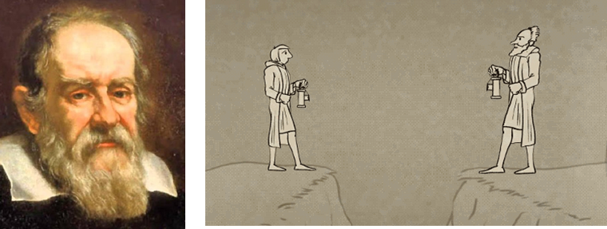

By opening and closing shutters of two lamps on two hills. He attempted to measure the time that elapsed between the opening and closing of the shutters. Since, there was no perceptible time tag, beyond human reaction time, Galileo concluded that the speed of light must be very great indeed.

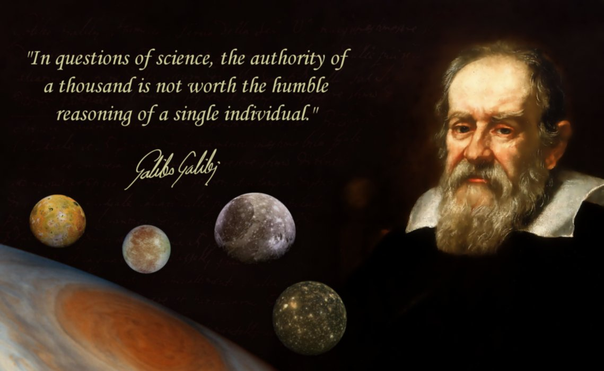

**Ole Romer used the moons of Jupiter to find the speed of light**

The first to give a finite estimate to the speed of light was the Dutch astronomer **Ole Romer** (1644-1710), although he did not

set out to measure the speed of light at all. Romer measured the times at which the moons of Jupiter disappeared behind the planet and noticed that these eclipses occurred earlier when the Earth was closer to Jupiter and later when the Earth was farthest away.

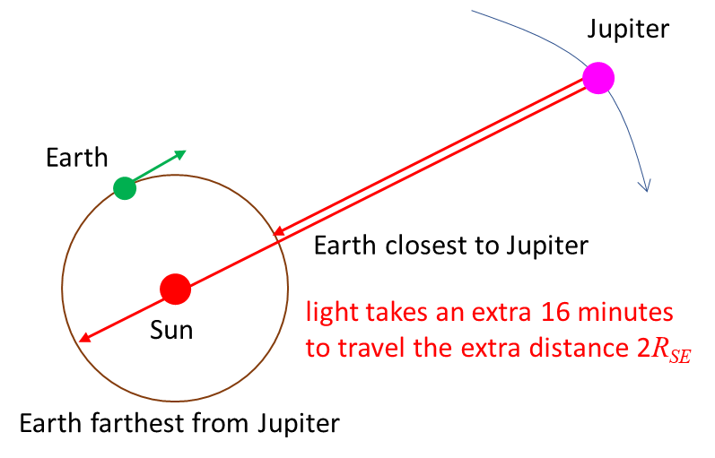

Fig.2. Moons of Jupiter enabled Romer to estimate the speed of light. When the Earth is at its greatest distance from Jupiter, light takes an extra 16 min longer to travel between them.

It takes about 16 minutes for light to travel from one side of the Earth’s orbit to the other and this is roughly the discrepancy in eclipse times observed by Romer. In 1676, he announced a value for the speed of light to be 2.2x108 m.s-1 (not a bad estimate for 1676).

Rough calculation



**Armand Fizeau rotating wheel to measure the speed of light**

The first laboratory measurement of the speed of light was performed by the French scientist **Armand Fizeau** (1819-1896). He used a mirror and a rotating notched wheel as shown in figure 3.

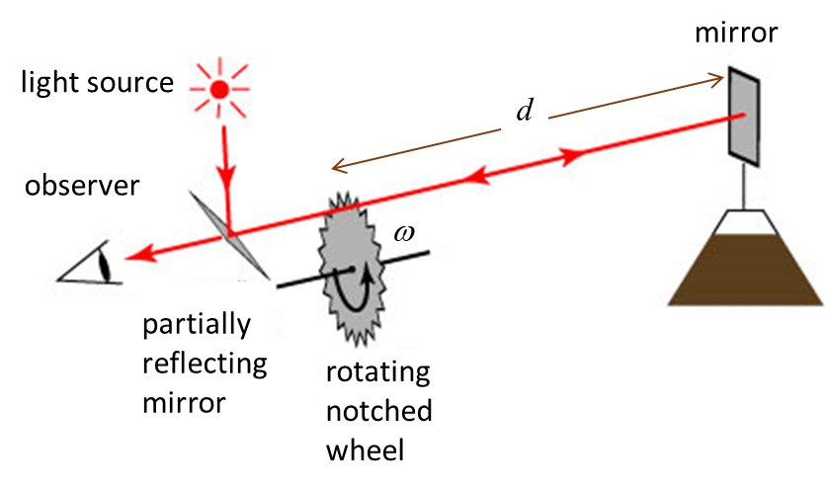

Fig. 3. Fizeau’s experiment to measure the speed of light. If the time required for the light to travel to the mirror and back is equal to the time it takes for the notched wheel to rotate from one notch to the next, the light will pass uninterrupted through each notch to the observer.

He used a light source, a mirror and a rotating notched wheel. Light passing through one notch travels to a mirror a considerable distance away and is reflected back to an observer. If the rotation speed of the notched wheel is adjusted, the light can pass through each notch to the observer. By measuring the distance from the mirror to the notched wheel and its rotation speed, Fizeau measured the speed of light to be 3.13x108 m.s-1 using his rotating wheel.

|  |
| --- |
| **Example 1**  Consider a Fizeau experiment in which there are 600 notches. Light passing through one notch travels to the mirror and back in time for it to pass through the next notch. If the distance to from the mirror to the notched wheel is 10 km, what is the rotation speed of the notched wheel?  **Solution**  number of notches  wheel-mirror distance  rotation speed of notched wheel  The angle between notches must be    The light travels a distance  at the speed    The time for the round trip for the light is    The rotation angle in this time is    So, the rotation speed of the notched wheel is |

**Contemporary method to measure the speed of light**

Maxwell’s prediction for the speed of light through non-magnetic material is used to estimate the speed of light in material matter.



Careful and very accurate measurements of  allows us to estimate very accurate measurements for the speed of light in a vacuum and material media. The prediction for the speed of light in a vacuum by Maxwell agrees with experimental values.

Today, experiments to measure the speed of light have been refined to such a degree, that we now use it to define the **metre**.

Thus, by **definition**, the **speed of light in a vacuum** is

 definition: speed of light in a vacuum

The **metre** is defined to be the distance travelled by light in a vacuum in 1/29979248 of a second.

Today, the most accurate timekeepers known as **atomic clocks** which are based upon characteristic frequencies of the electromagnetic radiation (waves) emitted by certain atoms. These atomic clocks have typical accuracies of about 1 second in 300 000 years.

The cesium-133 atom used in a cesium atomic clock is used to define the second. The **second** is defined to be the time it takes for radiation from a cesium-133 atom to complete

9 192 961 630 770 cycles of oscillation.

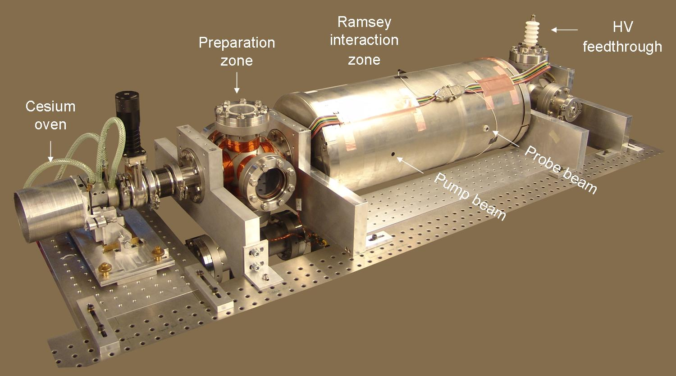

Atomic clocks are in common use. For example, the satellites for GPS (Global Positioning System) use atomic clocks to make accurate and precise time measurements that are needed for accurate and precise determinations of position and speed.

You can access the official U.S. time on your computer:

<https://time.gov/>

**The production of electromagnetic waves**

James Clerk Maxwell in 1861 predicted the existence of electromagnetic waves since a changing magnetic field produces

a changing electric field and a changing electric field produced a changing magnetic field. His equations showed a symmetry between the electric field and the magnetic field. From his mathematical model, he showed that electromagnetic waves should propagate as a polarised transverse wave at the speed of light. Thus, he proposed that visible light which had previously been thought of as a completely separate phenomenon from electricity and magnetism, was in fact, an electromagnetic wave. His theory implied that electromagnetic waves would not be limited to the visible light, but they could also be produced by oscillating electric circuits.

More than 20 years later, his prediction of the production of electromagnetic waves (radio waves) from an electric circuit were confirmed. The first production and observation of radio waves in the lab was done in 1887 by the German physicist, Heinrich Hertz (1857-1894). He used a capacitor C (two separated oppositely charged plates) and an inductor L (coil) in the form of an LC circuit to generate alternating current in a circuit. In another circuit several metres away, an alternating current was induced by the energy transferred from the LC circuit to the detector circuit. He showed that the energy transfer exhibited wave-like characteristics: reflection, refraction, polarization, interference, and diffraction. He made a rough estimate of the speed of propagation of the energy and that speed was the speed of light. Hertz had indeed discovered the fact that radio waves are produced in an oscillating electric circuit, thus confirming the predictions of Maxwell more than 20 years ago. Maxwell died in 1879, so he did not live to see his prediction confirmed.

A few years later, the Italian scientist Guglielmo Marconi (1874-1937) refined the work of Hertz to product the first practical applications of the generation of radio waves. He recognized the fact that radio waves could be used for communication, eliminating the wires necessary for telegraphy. He patented his first system in 1896. He became famous in 1901, when a radio signal was from Cornwell in England was received in StJohns in the Netherlands.

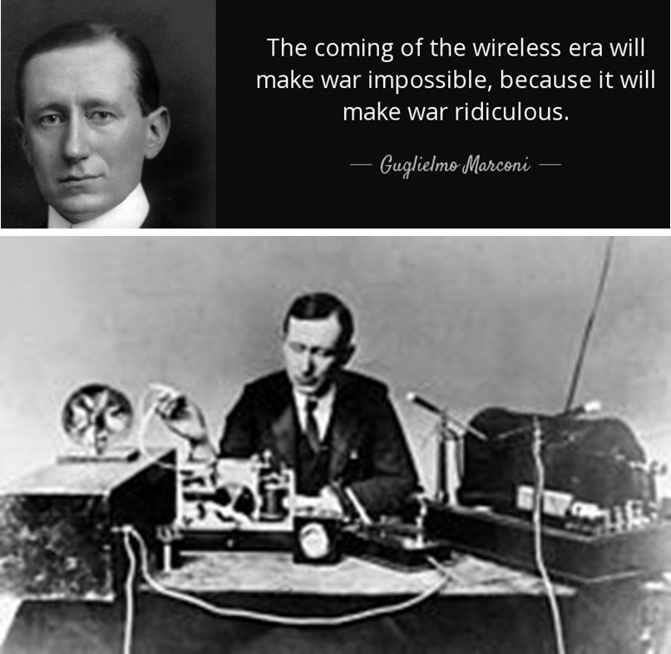

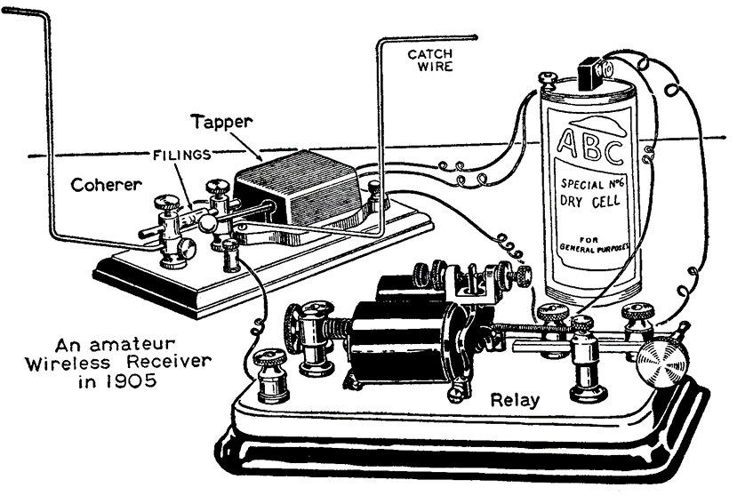

We will consider a simple antenna which is made of a long, straight wire with a break in the middle to illustrate the production of radio waves. A sinusoidal signal with period *T* is fed to the antenna from an AC generator as shown in figure 4.

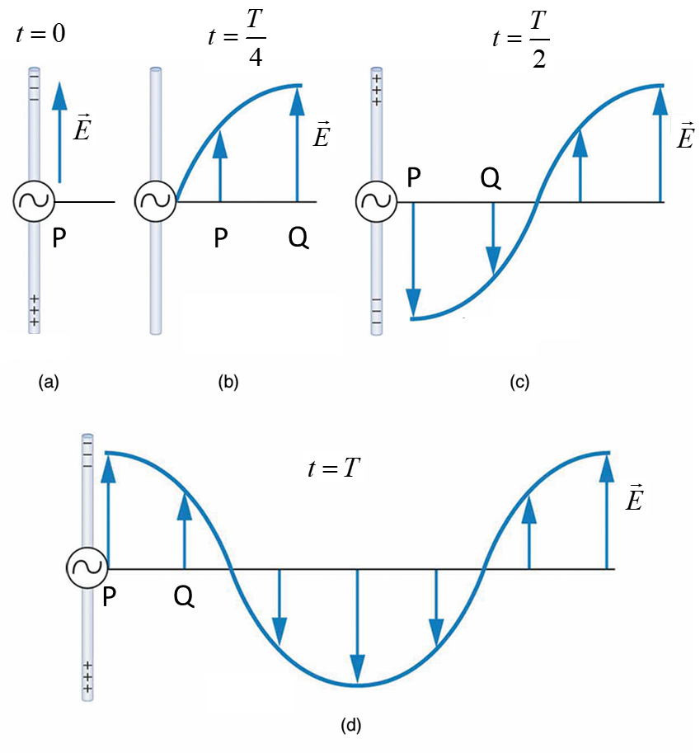

Fig. 4. A polarized travelling radio wave produced by an AC generator attached to the antenna. (a) At *t* = 0, the top half of the antenna has a maximum negative charge and the lower segment a maximum positive charge producing an upward acting electric field at point P near the antenna. (b) A short time later, the charge on the segments of the antenna is reduced, and the electric field at point P is reduced and the original field at P has moved to the point Q since the reduction in charge on the antenna is felt at point P before it is felt at Q as the electric field propagates at the finite speed *c.* (c) The charge on the antenna has reversed and the electric field at points P and Q are now in the downward direction. (d) After a period *T,* the wave has advanced one wavelength as the fields (electric and magnetic) produced at earlier times continue to move away from the antenna.

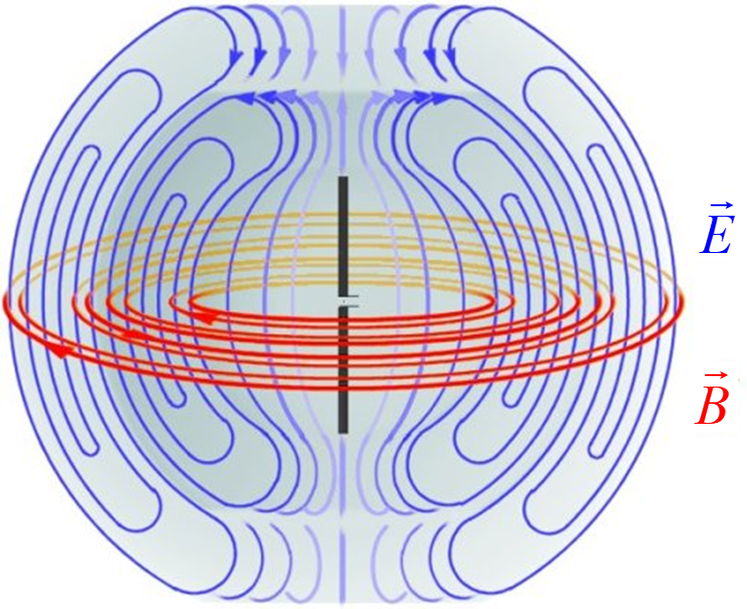

Fig. 5. Sequence showing electric and magnetic fields that spread outward from oscillating charges on the two conductors connected to an AC source. [View animation](https://en.wikipedia.org/wiki/Antenna_(radio)#/media/File:Dipole_xmting_antenna_animation_4_408x318x150ms.gif).

We have seen that electromagnetic waves are produced by electric charges that are oscillating in an antenna and hence undergoing acceleration. In fact, it is true that

**Electromagnetic waves are generated by accelerating electric charges**

Electromagnetic waves can be produced in other waves as well such as transitions between energy levels in atoms and nuclei.

Atomic transitions: hydrogen atom 

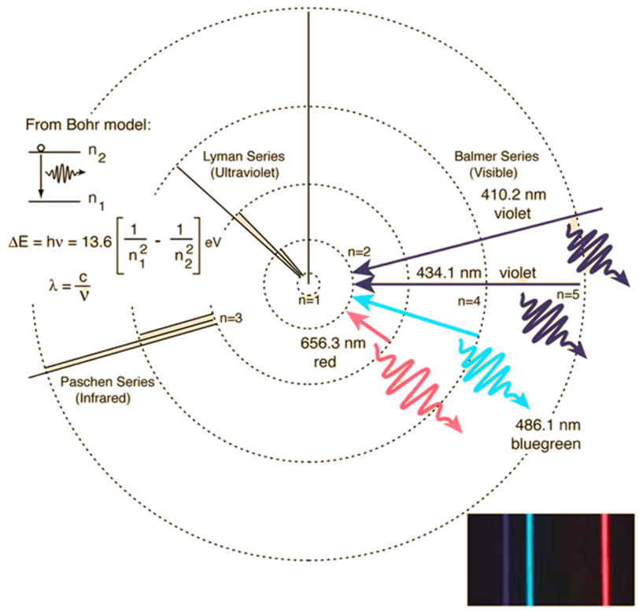

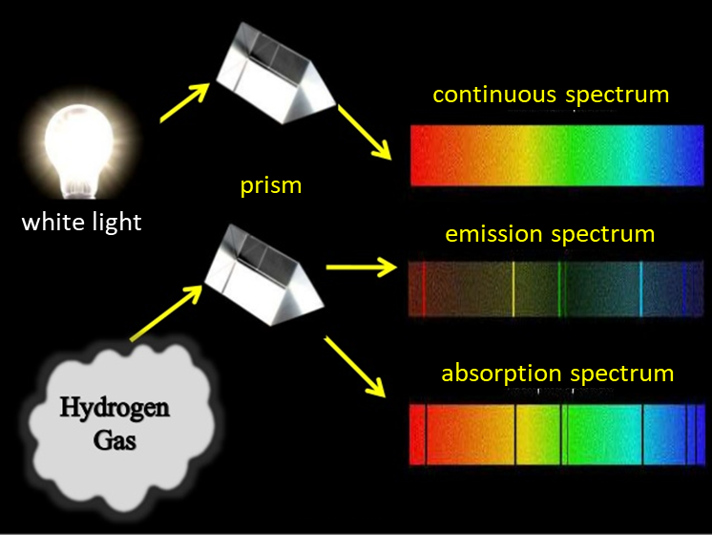

Nuclear transitions: 

Gamma-rays () are very high frequency (short wavelength) electromagnetic waves emitted from unstable radioactive nuclei.

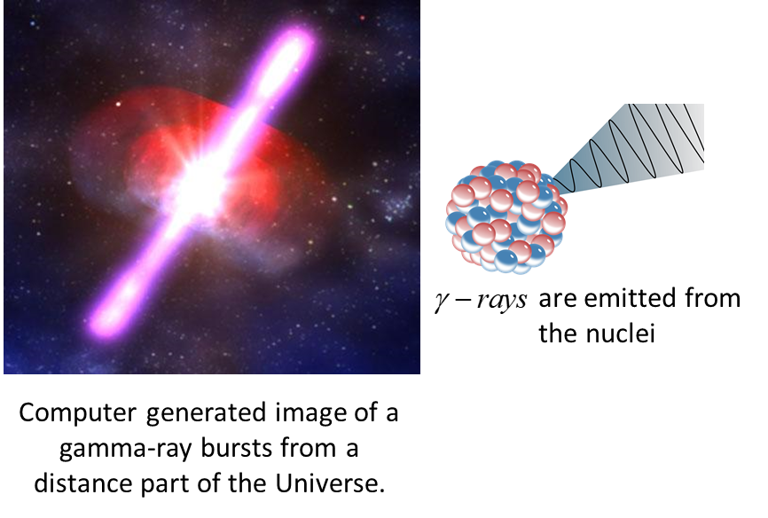

“The precise formulation of the time-space laws was the work of Maxwell. Imagine his feelings when the differential equations he had formulated proved to him that electromagnetic fields spread in the form of polarised waves, and at the speed of light! Too few men in the world has such an experience been vouchsafed ... it took physicists some decades to grasp the full significance of Maxwell's discovery, so bold was the leap that his genius forced upon the conceptions of his fellow workers.”

(Albert Einstein, May 24, 1940)

[VISUAL PHYSICS ONLINE](http://www.physics.usyd.edu.au/teach_res/hsp/sp/spHome.htm)

http://www.physics.usyd.edu.au/teach_res/hsp/sp/spHome.htm

If you have any feedback, comments, suggestions, links or corrections please email: ian.cooper@sydney.edu.au

Ian Cooper School of Physics University of Sydney